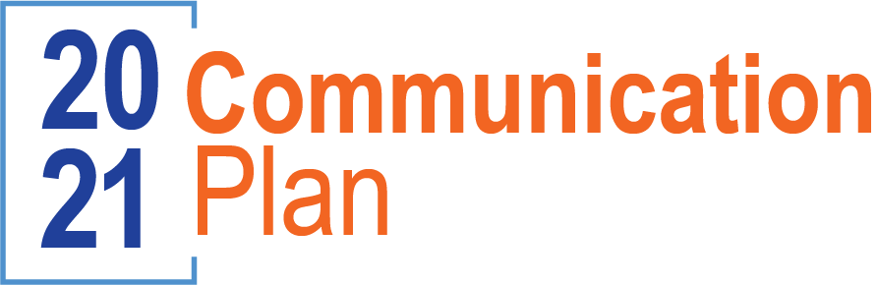

January
Admin email | User email
QBR
Webinar
Lunch and Learn
February
Admin email | User email
QBR
Webinar
Lunch and Learn
March
Admin email | User email
QBR
Webinar
Lunch and Learn
April
Admin email | User email
QBR
Webinar
Lunch and Learn
May
Admin email | User email
QBR
Webinar
Lunch and Learn
June
Admin email | User email
QBR
Webinar
Lunch and Learn

July
Admin email | User email
QBR
Webinar
Lunch and Learn
August
Admin email | User email
QBR
Webinar
Lunch and Learn
September
Admin email | User email
QBR
Webinar
Lunch and Learn
October
Admin email | User email
QBR
Webinar
Lunch and Learn
November
Admin email | User email
QBR
Webinar
Lunch and Learn
December
Admin email | User email
QBR
Webinar
Lunch and Learn

